ecrNow Project Setup Instructions

Step 1: Create the Folder Structure
- Open your terminal or file explorer.
- Navigate to the directory where you want to create the ecr-now project.
- Create the main project folder named ecr-now.
- Inside the ecr-now folder, create the following subdirectories:
  - schematron
  - schemas
  - kars
    - electronic-case-reporting
  - bsa-output
  - custom-queries

ECR-NOW FOLDER STRUCTURE
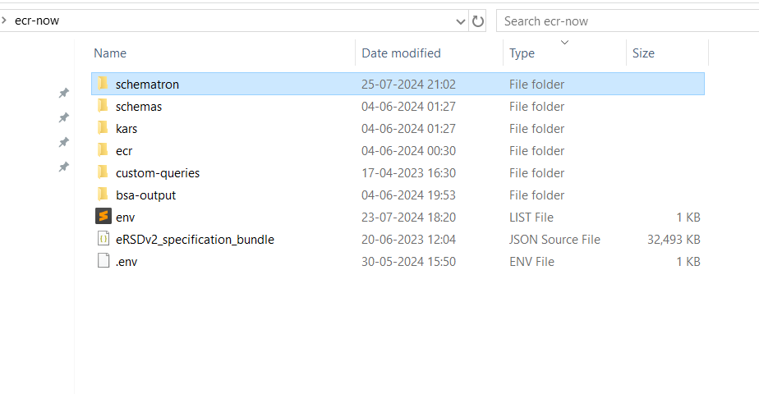

The folder structure should look like this:
  - ecr-now/
  - ├── ecrNow.log
  - ├── eRSDv2_specification_bundle.json
  - ├── schematron/
  - │ └── CDAR2_IG_PHCASERPT_R2_STU1.1_SCHEMATRON.sch
  - ├── schemas/
  - │ └── CDA_SDTC.xsd
  - ├── kars/
  - │ ├── electronic-case-reporting/
  - │ └── eRSDv2_specification_bundle.json
  - ├── bsa-output/
  - ├── custom-queries/

Step 2: Place the Files in the Appropriate Folders
- ecrNow.log
  - Location: ecr-now/
  - Description: Log file for the application.
  - How to Obtain: This file will be created by the application at runtime.

- eRSDv2_specification_bundle.json
  - Location: ecr-now/
  - Description: The eRSD v2 specification bundle in JSON format.
  - How to Obtain:
ERSD file can be downloaded by registering for an account at : https://ersd.aimsplatform.org Currently this link only works state-side and if you are out of country, please contact us to figure out how we can get you a copy of it through the right means.
  - For Release 2.X of the application, the ERSD v1 Specification Bundle should be used.
  - For Release 3.X of the application using the systemLaunch API, the ERSD v1 Specification Bundle should be used.
  - For Release 3.X of the application using the launchPatient API, the ERSD v2 Specification Bundle should be used.
- SCHEMATRON DIRECTORY
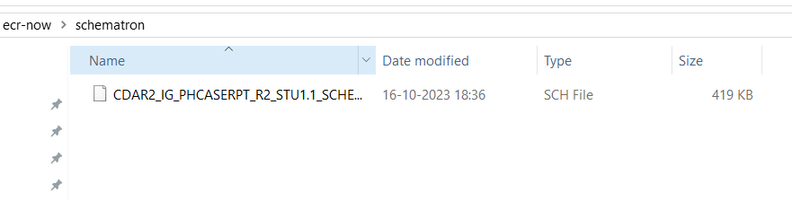
  - Location: ecr-now/schematron/
  - Description: CDAR2_IG_PHCASERPT_R2_STU1.1_SCHEMATRON.sch
Schematron file for validating CDA R2 PHCase reports.
  - How to Obtain: Download from the official HL7 website or the project repository.
- Schemas DIRECTORY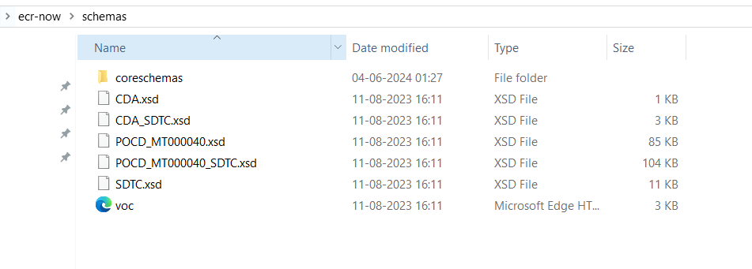
  - Location: ecr-now/schemas/
  - Description: XML Schema Definition (XSD) file for CDA SDTC.
  - How to Obtain: Download from the official HL7 website or the project repository.

- KARS DIRECTORY(Knowledge Artifact Repository)
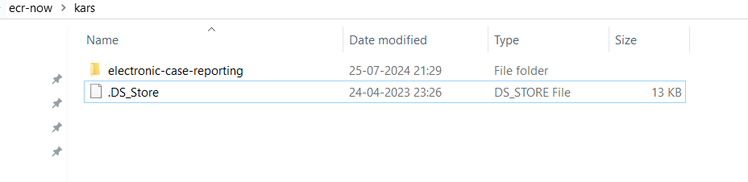

5.1 Electronic-case-reporting DIRECTORY
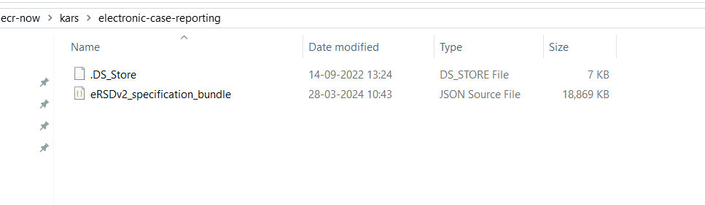
  - Location: ecr-now/kars/electronic-case-reporting/
  - Description: Directory to store KAR files for electronic case reporting.
  - Files to Include: eRSDv2_specification_bundle.json
  - How to Obtain: Files will be downloaded by the ESRD Website(https://ersd.aimsplatform.org/#/home)

- Bsa-output DIRECTORY
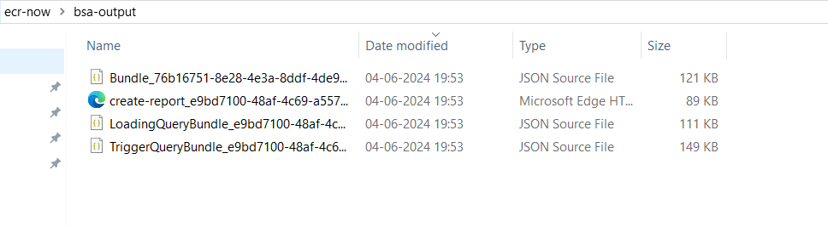
  - Location: ecr-now/bsa-output/
  - Description: Directory to store BSA (Business Service Automation) output files.
  - How to Obtain : The application will generate the creat-report.xml, LoadingQueryBundle.json, and TriggerQueryBundle.json files upon making the Launch Patient API call.

- Custom-queries DIRECTORY
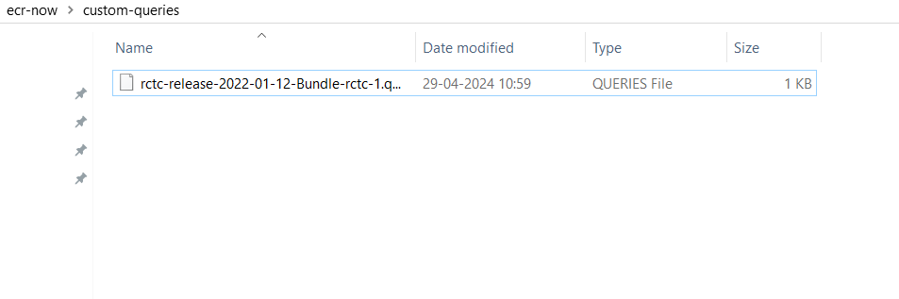
  - Location: ecr-now/custom-queries/
  - Description: Directory to store custom query files.
  - How to Obtain: we will be create custom Queries File

